**Exercise 1: Ranking and Window Function**

**-----> ORIGINAL TABLE:-**

**CREATE TABLE Products (**

**ProductID INT PRIMARY KEY,**

**ProductName VARCHAR(100),**

**Category VARCHAR(50),**

**Price DECIMAL(10, 2)**

**);**

**INSERT INTO Products (ProductID, ProductName, Category, Price) VALUES**

**(1, 'Laptop', 'Electronics', 1200.00),**

**(2, 'Smartphone', 'Electronics', 800.00),**

**(3, 'Tablet', 'Electronics', 600.00),**

**(4, 'Headphones', 'Accessories', 150.00);**

**(5, 'Mobile Guard', 'Protection', 140.00),**

**(6, 'Mobile Cover', 'Protection', 200.00);**

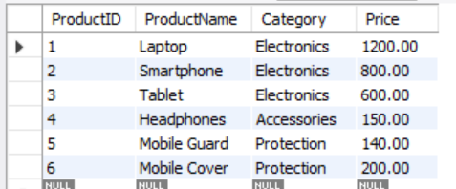

**Find the top 3 most expensive products in each category using different ranking function-**

**> Using ROW_NUMBER()**

SELECT

ProductName,

Category,

Price,

ROW_NUMBER() OVER(PARTITION BY Category ORDER BY Price DESC) as RowNum

FROM

Products;

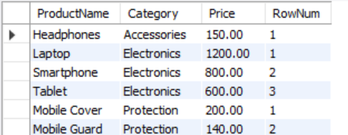

**2. Using RANK() and DENSE_RANK()-**

SELECT

ProductName,

Category,

Price,

RANK() OVER(PARTITION BY Category ORDER BY Price DESC) as RankNum,

DENSE_RANK() OVER(PARTITION BY Category ORDER BY Price DESC) as DenseRankNum

FROM

Products;

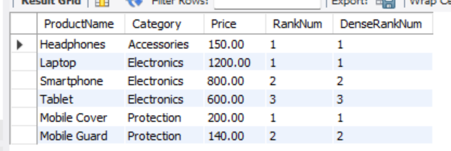

**3> Use PARTITION BY Category and ORDER BY Price DESC -**

**WITH ProductRanks AS (**

**SELECT**

**ProductName,**

**Category,**

**Price,**

**DENSE_RANK() OVER(PARTITION BY Category ORDER BY Price DESC) as DenseRankNum**

**FROM**

**Products**

**)**

**SELECT**

**ProductName,**

**Category,**

**Price,**

**DenseRankNum**

**FROM**

**ProductRanks**

**WHERE DenseRankNum <= 3;**

